PROJECT TITLE
IMPLEMENT CLIENT SCRIPT &UI POLICY (INCIDENT)
6. Project Testing Phase

Date: | 29.09.2026
Team ID: | SWTID-2026-2139
Project Name: | Implement Client Script & UI Policy (Incident)

6.1 Introduction
The Project Testing Phase is the sixth phase of the project “Implement Client Script & UI Policy (Incident)”. This phase is carried out after completing the development of the Client Script and UI Policy in the ServiceNow Incident module.
The main purpose of testing is to verify whether the implemented functionality works according to the requirements and design. The Incident form is tested under different conditions to check whether the Client Script and UI Policy perform the expected actions.
Testing also helps identify configuration errors, incorrect field behaviour, validation problems, and other issues. Any issues found during testing are corrected before the final project demonstration.

6.2 Objectives of Testing
The main objectives of the Project Testing Phase are:
- To verify that the Client Script works correctly.
- To verify that the UI Policy works correctly.
- To check whether the defined conditions are applied correctly.
- To verify the behaviour of the selected Incident fields.
- To check mandatory field validation.
- To check read-only or visibility behaviour where applicable.
- To verify that the Incident form responds correctly to user input.
- To identify and correct errors.
- To ensure that the project requirements are satisfied.
- To prepare the project for final demonstration.

6.3 Testing Environment
Testing is performed in the same ServiceNow environment used during the development phase.
The testing environment consists of:
- ServiceNow platform
- Incident Management module
- Incident form
- Configured Client Script
- Configured UI Policy
- UI Policy Actions
- Web browser
- Internet connection
The testing is performed using an Incident record and different field values.

6.4 Testing Approach
The project follows a simple testing approach.
First, the Incident form is opened and the initial values are checked. Then, the values of the relevant fields are changed according to the conditions defined in the Client Script and UI Policy.
The system response is observed after each change.
The testing process includes:
- Open the Incident form.
- Enter or select the required values.
- Change the relevant field.
- Observe whether the Client Script is triggered.
- Check whether the UI Policy condition is satisfied.
- Observe the field behaviour.
- Verify the expected result.
- Record the test result.
- Correct any issue if the expected result is not obtained.

6.5 Client Script Testing
The Client Script is tested to verify whether it performs the required client-side operation.
The relevant Incident field is changed according to the defined condition.
The following points are checked:
- Whether the Client Script is active.
- Whether the correct field triggers the script.
- Whether the condition is evaluated correctly.
- Whether the expected action is performed.
- Whether the user receives the required validation or response.
- Whether the form continues to work correctly after the action.
If the expected result is obtained, the Client Script test is considered successful.

6.6 UI Policy Testing
The UI Policy is tested by entering different values into the relevant Incident fields.
The purpose is to verify whether the UI Policy applies the configured field properties when its condition is satisfied.
The following properties are checked where applicable:
- Mandatory
- Read-only
- Visible
For example, if the UI Policy is designed to make a field mandatory under a particular condition, the team checks whether the field becomes mandatory when that condition occurs.

6.7 Test Cases
The following test cases can be used for the project.

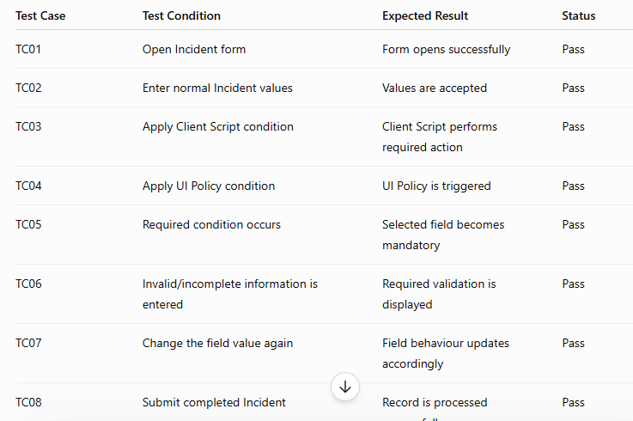

Note: Change the Status to Pass/Fail based on your actual testing results.

6.8 Positive Testing
Positive testing checks whether the system works correctly when valid values are entered.
For example, the team enters the required Incident information and applies the condition defined for the Client Script or UI Policy.
The expected behaviour should occur without errors.
Positive testing verifies that:
- Valid information is accepted.
- The Client Script performs the expected action.
- The UI Policy applies the correct field properties.
- The Incident form behaves normally.

6.8 Positive Testing
Positive testing checks whether the system works correctly when valid values are entered.
For example, the team enters the required Incident information and applies the condition defined for the Client Script or UI Policy.
The expected behaviour should occur without errors.
Positive testing verifies that:
- Valid information is accepted.
- The Client Script performs the expected action.
- The UI Policy applies the correct field properties.
- The Incident form behaves normally.

6.9 Negative Testing
Negative testing checks how the system behaves when required information is missing or incorrect.
For example, if a field becomes mandatory under a particular condition, the team attempts to continue without entering that field.
The system should provide the expected validation and prevent incomplete information from being processed when appropriate.
Negative testing helps verify that the implemented validation is working correctly.

6.10 Validation Testing
Validation testing is performed to verify whether the system identifies incomplete or incorrect information.
The team checks whether the appropriate validation message or field indication appears when the required condition is satisfied.
For example, in the Incident form, if Assigned To becomes mandatory for a particular condition, the team verifies that the system indicates that the field must be completed.
This helps improve the accuracy and completeness of Incident records.

6.11 Before and After Testing
The Incident form is observed before and after applying the defined conditions.

Before Testing
The Incident form is in its normal state and the selected field does not yet show the condition-specific behaviour.

After Applying the Condition
The relevant field changes according to the Client Script or UI Policy.
For example:
- A field becomes mandatory.
- A field becomes read-only.
- A field becomes visible or hidden.
- A validation message is displayed.
The before-and-after comparison helps demonstrate that the implementation is working as intended.

6.12 Error Identification and Correction
During testing, any unexpected behaviour is recorded and investigated.
Possible issues include:
- Client Script not triggering.
- Incorrect condition.
- Incorrect field selected.
- UI Policy not applying.
- UI Policy Action configured incorrectly.
- Validation not appearing.
- Field behaviour not changing as expected.
The configuration or script is reviewed and corrected when necessary. The affected test case is then repeated to verify the correction.

6.13 Test Results
After completing the testing activities, the results are reviewed.
The testing confirms whether:
- Client Script works as expected.
- UI Policy works as expected.
- Required field behaviour is applied.
- Validation works correctly.
- The Incident form responds to user input.
- The project requirements are satisfied.
The final test results are documented as evidence of successful implementation.

6.14 Final Testing Outcome
The testing phase verifies the functionality developed during the Project Development Phase.
The Client Script and UI Policy are checked under different conditions to ensure that the Incident form behaves according to the defined requirements.
Any issues identified during testing are corrected before the final demonstration.
After successful testing, the project is ready for the Project Documentation Phase and Project Demonstration Phase.

6.15 Screenshots for Project Testing Phase
Screenshot 1 — Incident Form Before Testing
Incident Form Before Testing
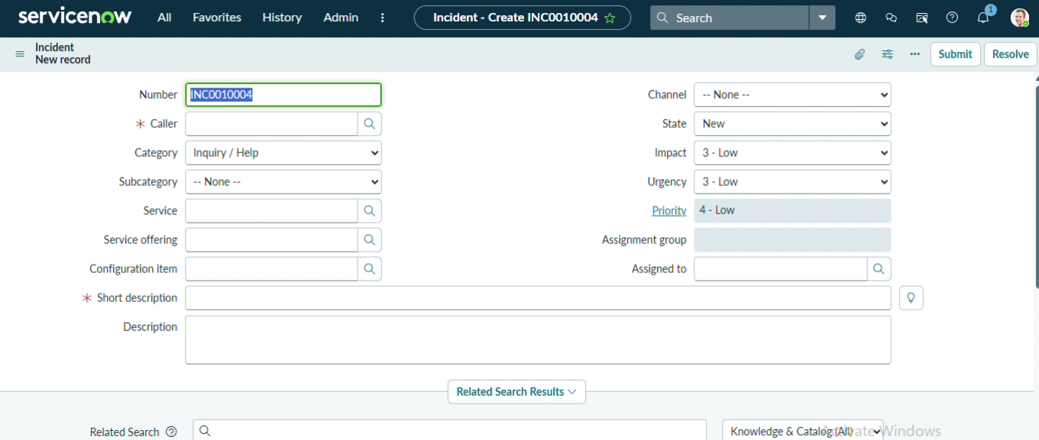

Screenshot 2 — Condition Applied
Incident Form with Required Condition Applied
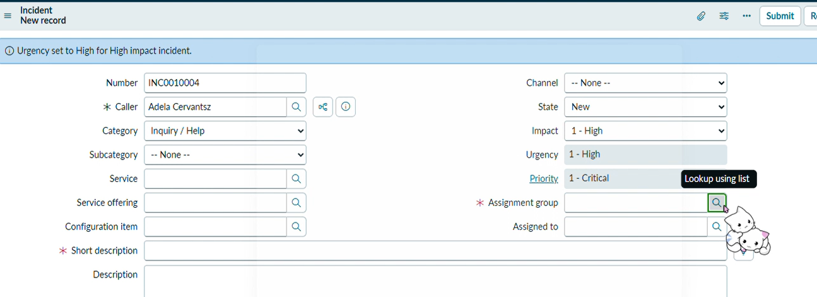

Screenshot 3 — Field Behaviour After Condition
Field Behaviour After Applying Client Script and UI Policy
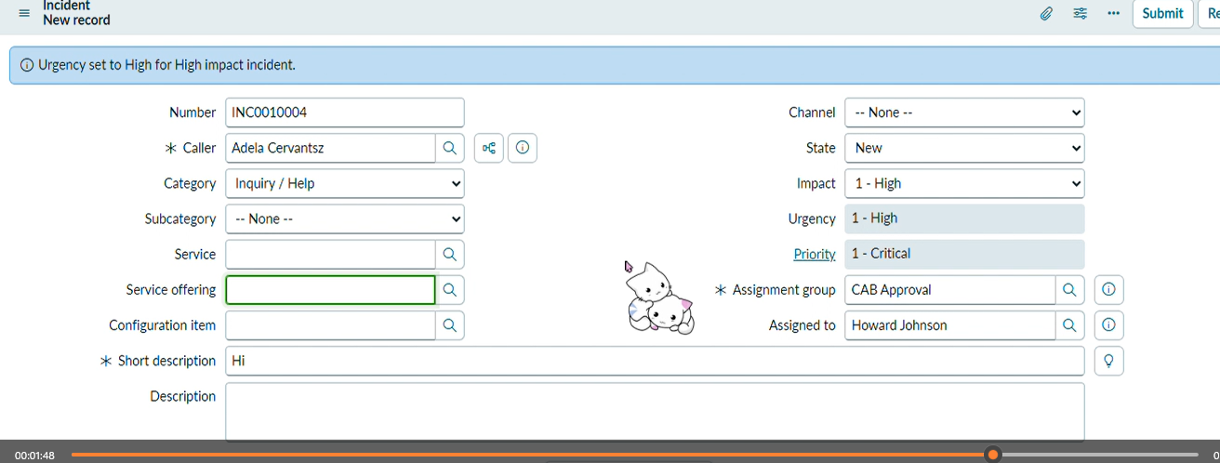

Screenshot 4 — Validation Message
Validation Message Displayed During Testing
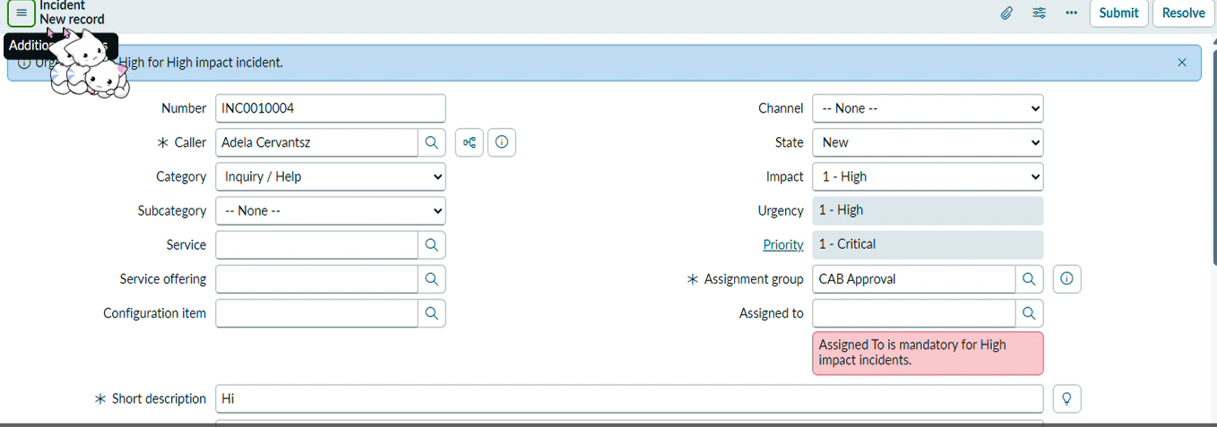

Screenshot 5 — Successful Final Test
Figure 17: Successful Testing of Incident Form

